Dayforce Employee FAQ’s
Q: Time Away from Work requests default to 8 hours, how many hours do I need to request for a full day?
A: If you would like to request time off for a full day, the number of hours requested should match the number of hours you work per day. Dayforce defaults to 8 hours.
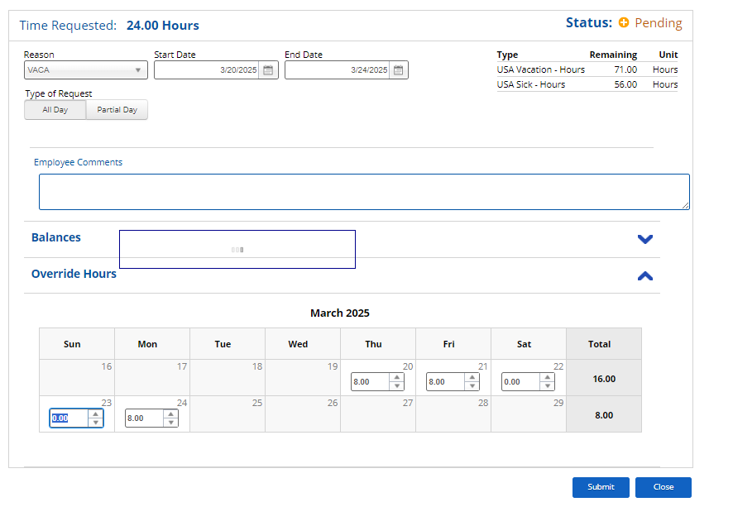
Note: If the request includes a weekend (ie. Thursday through Monday) but you do not work weekends, you will need to use the override hours feature to remove the hours on Saturday and Sunday.

Q: Does Dayforce have a Community page where company announcements are communicated and housed like Paylocity did?
A: Dayforce will not send out company announcements, you can find all company announcements on AXIS – MMX Intranet! Additionally, important Human Resources messages can be found at the top of the Dayforce Hub (homepage).

Q: I used to be able to submit timecard corrections in Paylocity. Can I do the same in Dayforce?
A: No, you are not able to submit timecard corrections in Dayforce. You will need to notify your supervisor/manager for any timesheet corrections.
Q: What is the difference between Grants and Accruals?
A: The Med-Metrix Vacation and Sick Time policy continues to front load time at the beginning of the year.
- Grant time: the amount provides you with the total annual time.
- Accrued amount: how much time you have accrued on a monthly basis.
- Remaining Grant: the annual grant minus time used. This reflects the current available balance through the end of the calendar year (based on continued employment for the entire calendar year).
- Remaining: the remaining balance of unused accrued time.
You can review your amounts on the Balance Summaries Page.
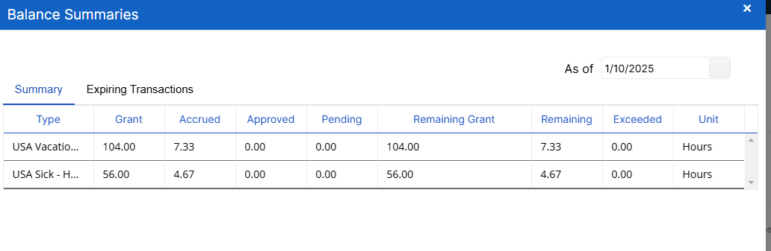

Please refer to your Dayforce Hub Page for any policy, guides and reference materials for additional assistance. If you have any questions, please reach out to your HR team.

